

*High Street, Wombourne, South Staffs, WV5 9DN*

***2019 Kingsway AGM Report***

***Held on: Sunday 4th August 2019***

***Living for Jesus*,**

***Transforming Lives*,**

***Building Community***

KINGSWAY CHURCH - Ministry Report for 2018/19



**Kingsway Church People & Small Groups:**

* Living for Jesus, Transforming Lives, Building Community is our mission statement and is a great statement of who we exist for and what our mission is.
* We know what is essential for good discipleship and that is Prayer, Bible study and meeting together – and that’s what our church and small groups are all about.
* Looking at the church as a whole, a formal membership is needed to ensure proper governance of our church family and enables us to be properly constituted as far as the Assemblies of God and the charity commission is concerned. We want as many regular attenders as possible to be members.
* Church membership dropped slightly through 2018 from 103 to 98.
* This does not however reflect the church’s impact on the community as we touch many hundreds of people through our activities and our meeting room is regularly full (~250) for our morning services.
* Now for our small groups in which we have 134 people involved in 13 groups with 23 leaders which meet either at church or in homes throughout the week.
* From this autumn it is great that Mal and Ann will be joining Paul this year to work at developing this ministry which is essential for discipling and family growth.
* On alternate weeks to our small groups we have our Prayer Meetings, vital to the Churches health and wellbeing.

God is doing great things amongst us so we need to continue to seek His guidance and prepare for new group leaders for new groups for new people.

*Paul Freeman*

**Kingsway Worship:**

Our aim is to lead the congregation into thanksgiving praise and worship.

Everything must glorify God.

The different aspects of thanksgiving, praise and worship

1. By thanksgiving we acknowledge God’s goodness

2. By praise we acknowledge God’s greatness

3. By worship we acknowledge God’s holiness

Corporate worship on Sundays must go alongside solo worship at home.

It’s a difficult task to lead - song choice (old/new), style, the right key, including an age range of toddlers up to some of you ancients of days and everyone in between.

Thanks to all in team - team is everyone who makes it possible, musicians, singers, PA, computer people.

Good to have Dave B back after his accident, special thanks to Jo and David Field who stepped in to cover the extras.

Lastly, if you are blessed by what we do, tell the guys; if you have an idea for a song that we should do then tell us. We are here to serve

*Mark Price*

**Community:**

Thank you to all who are involved with the Welcome Teams, they are the public face of Kingsway and many guests comment on the warm welcome they receive. New members for the teams are required.

None church members are very appreciative of the prayer partners concern shown for their family members that are prayed for each week.

Thanks was made to Betty, Tony & Jayne for producing the weekly and monthly notice sheets informing members and the wider community via the website and Facebook page of events taking place at Kingsway.

The success of special events held at Kingsway was reported, the Elves Workshop where a queue from the church door across the car park  was formed to gain entry, the Easter Egg Hunt and the Scarecrow Festival.

A successful Alpha Course utilising the HTB filmed talks was run in the new year with four full tables of attendees ranging in age from teens to 80 plus.

The Foodbank continues to meet the needs of individuals and families in South Staffordshire with 189 deliveries being made in 2018 and 152 so far in 2019.

Free flowers are distributed by 'Niche' with good reports received from recipients.

*Stewart Revitt*

**Finance:**

2018 - the accounts were heavily affected by the church extension, achieved at a cost of £0.5 million. Excluding the extension income was £5,000 below expenditure due to a  delay in receiving the final quarters gift aid. An appeal was made to everyone to gift aid their giving as this will increase by 20% the amount they give to the church.

2019 Jan to June. - The accounts look healthy so far this year although there are a number of items that are not paid until the second half of the year,  it is anticipated that Income will exceed Expenditure even though the church is now paying over £1,700 per month for the £355,000 mortgage with Kingdom Bank.

See finance results at the end of this report

*Stewart Revitt*

**Children & Youth Ministries:**

**Fizz**

* Numbers of children attending from reception to age 8.

16 – 22 children each week on average

26 on the register

11 on the waiting list

2 going up to Infusion September

9 going up to Infusion January

* Leaders:

5 adult leaders for the last year – (often less than this due to holidays, illness and family commitments)

3 Younger leaders for the last year

From Sept will be 4 adult leaders and 1 younger leader

* Resources used/Bible themes:

Autumn term – Joseph, Jonah, Samuel and the Christmas story. Mustard seed programme used.

Spring term – Jesus grows up and the Easter story/Gospel message – various resources used- the Miracle maker DVD, YouTube clips etc.

Summer term – ‘Out in the Wild’ Arctic chill – resource from life Church – various Bibles stories used and linked in with how God wants us to use our words. DVD, song, activities all themed on going on an outdoor adventure and fun for the kids.

* Highlights:

Children appear to enjoy the group and are keen to bring friends. Good relationships with families. Talent show and messy Church went down well and several signed up for the holiday club.

* Challenges:

Adapting to a younger age group. (Children attend now from reception to keep continuity from preschool groups and go up at age 8 – some have gone up even earlier to make room for those waiting.)

Ensuring the smooth running of the group, whilst coping with leader shortages (illness, exams, holidays), and children with behavioural issues/special needs.

Children wanting to attend Friday groups after the Pulse group – We cannot safely accommodate them at present and have a waiting list which is causing concern.

**To encourage the children in faith and to welcome their families into Church….   
We hope and pray that the seeds of faith are sown and that ultimately whole families are saved….**

**Paul Wilmott:**

Westfield and Blakeley. Lessons, assemblies, monthly Fizz and Infusion, Christian TV, special events like Good Friday march of witness.

**Thrive**:

Meets Mondays - Hannah, Charlie, Kat, Jos, Beth, Lydia, Kendrick, Issy, Nancy and Sally. Test to see if post 16s will come.

Leaders, Claire, Sam, Laura, Enid and GD. Lost Amy earlier this year. Need at least 2 more leaders. Explored lots of Christian topics from, “caring for your soul” to praying in tongues and using the gifts of the Holy Spirit.

**Blaze**:

Most difficult group ever. average 35, but have some breakthroughs in kids joining us in the Study for prayer. Some want to do a residential. £115

Leaders - Nick, Dave Bourne, Alan, Warren, Katie, Madeline, Zoe, John C, GD, Justine, Elaine. Always had sufficient to maintain ratios.

Mal and Ann stood down at Christmas, thanks to them.

Tom and Harry set up filming services. Connection to be made upstairs to mailroom and Cafe screens.

**Chaplains**:

Helen T and Helen W stood down at Easter to take on KingsKidz. We have Katie, Janet and Farrah on Tuesdays, Enid and GD on Thursdays.

Took Andrew to speak to 6th. formers from all 6 schools with the offer of going to Thailand and visiting Rainbow House in February.

3 of us were interviewers for Y10s mock interviews.

Alan attended awards evening as Wombourne Science and History group awards presented.

Hoping to offer something around mental health issues in November through Flame Trust.

Worked with Matt Brooks to set up 4 schools in the Dudley MAT with chaplains. Hopeful of establishing this in Dudley College.

3 training sessions at Kingsway at end of September, beginning of October led by Deb Walton from Kinver. Mondays, 4.30 p.m. to 6.00 p.m.

*Gerry Denston, Liz Trainor & Helen Trask*

**Junior Church**

* Liz and I now jointly share the leadership role of Junior Church. We plan and purchase the crafts for the group.
* Numbers of children fluctuate each week depending on which parents are in church. We can have from between 8-35 children.
* We’ve been using a variety of planning this year but are now using a scheme this year and adapting it to suit our own church needs.
* Exciting changes- we are fortunate to have extra team this year so we are able to split the children into 3 groups (TOTS- nursery to end of reception, WARRIORS- up to age 8, and ALIVE age 8-11)
* We have been thinking about how to incorporate Jarod Cooper’s prophecy, which we have been looking at in leadership meetings into our planning. We want to encourage our children to become involve in our church. We want to also incorporate ideas on ‘intergenerational church’ into our plans.

The biggest challenge we face in Junior Church is a need for more leaders. We have 5 at present, 3 of whom will alternate between the ‘creche’ group, which leaves Liz and Helen to cover the other 2 groups, meaning we don’t have much time to be in church being ‘fed’. Please pray for more leaders to come along side us and support.

**Infusion**

* We feel that this has been our best year yet at Infusion. But…we have so many exciting plans for this coming year.
* We have seen numbers of children attending peaking in the 40s this year .
* We have 3 regular team from Wombourne High School who come and help on a Friday night. These children have also helped at PULSE Holiday club this year too. We also have Junior Helpers too.
* The children have free time, football craft, air hockey, games, tuck shop, bouncy castle, and then they hear God’s word, questions and have prayer time too.
* We have new team members this year, including Dave Baker. This will allow us to split the children into smaller groups for question time after the word. Hopefully this will allow for more personal and focussed prayer and for the children to share their own thoughts in a smaller group. It will also allow us to get to know the children better as individuals.
* Please pray that these changes go smoothly and that the children respond to the Holy spirit.

**Kingskidz**

* We have 2 groups at kingskidz (Tuesday and Thursday mornings 10:00-11.30)
* The aim of the groups is to build relationships with parents of the toddlers an provide a safe, welcoming environment for the children to play in. it as noted by Pete Oakley from PULSE how apparent our relationships are with the parents an ho hay they seem to bring their children into Kingsway.
* We have toys, craft, song, prayer, Storytime, drinks, toast and fruit.
* We have nearly 40 children (plus their parents ) on the list for each session and we also have a small waiting list too.
* So far, since taking over at Easter our topics covered have been: pets, the zoo and summer holidays.
* The biggest challenge we face at Kingskidz is people. We desperately need more help on tea and toast (refreshments) and I also need people to help set up on a Monday morning.
* Please pray that people will help out at our group and that the parents will feel God’s love as we welcome them into our groups.

**Extra Activities**

* Once again, we had the scarecrow hunt, Easter egg hunt and the Elf Workshop. We also hosted the first ‘Messy Church’ where over 80 children attended with their parents. They did crafts, heard a word from Paul Wilmott on the Easter theme, and ate together. We have another messy church scheduled in the Autumn.
* We also hosted PULSE holiday club, where over 90 children had loads of fun, played games, did crafts, prayed together, and heard important messages from God, including Miracle Day and Gospel Day. We saw lots of children praying together by the end of the week and many made responses to the Gospel Message.

*Helen Trask*

**New Horizons:**

* We continued with much the same format over the last 18 months sharing together every Wednesday with a meal, some worship with prayers and a talk to inspire us.
* 25-28 people attend most weeks with occasionally more
* We are conscious that we are the only social contact for some who join us
* We held some events with a difference this last year
  + A fish & chip lunch which went down well both with the shop and our members!
  + An Easter Bonnet parade which was fiercly competitive but great fun with prizes
  + James Emtage & Karen came to sing and play which was very enjoyable and we invited them back for a Christmas carol sing-along
* We have donated to charity instead of swapping Christmas cards for many years now. We raised and gave £200 to Air Ambulance, Action Heart, Air Ambulance for Kids, Salvation Army.
* We would like to open this up for the whole church to engage with this year
* We gave aid to a friend of Ann’s in S Africa who was in serious difficulties
* We also gave Christmas chocolates and Easter eggs to the food bank to go out with deliveries over the festive periods
* After Jon came to speak to us about the work of the BCM with the homeless we decided to collect and donate toiletries for them which the homeless could use when they went to BCM to shower and wash.
* We celebrate everyone’s special days and in the case of Edie, we laid on a full celebration of her 90th Birthday.
* Edie’s sowing group have joined NH on a couple of occasions which was good
* Next year NH will celebrate its 25th anniversary
* There is always an open door at NH if you want to come along, share a testimony and share a talk with us.

*Janice Eagleton*

**Pastors Report**

The idea behind our new style AGM is to give updates on ‘where we are NOW!’ as a church.

**Well, to be honest, I think that we’re right back to where we started, when Judith and I came!?**

Let me explain that …..

* **PHYSICALLY** the church has changed dramatically …..

Lots of upgrades over the years

New toilets

Corridors upgraded

The biggest upgrade being this new worship area, which I love.

That has freed upstairs for youth and kids and toddlers.

What a great space that is for them!

Just had new blinds fitted in the old upstairs room.

Lots of improvements to the physical church.

Many, many thanks for your wonderful giving financially to make it all possible!!!

PHYSICALLY the church has changed ….

* **Secondly, the AGE PROFILE** of the church has also changed dramatically ….

We are multi-generational.

We have at least FOUR - possibly FIVE - different generations here at Kingsway now.

1. The generation before me were called The Silent Generation.

They ran from the 1920’s to the early 40’s.

1. I’m a baby boomer – born just after World War 2.
2. Gen X followed the baby boomers – born mid 60’s to early 80’s.
3. We now have millennials – born since the year 2000.

In our Leadership Forum, we have people from 14 years to 80 years …. !

In our services, we have kids to octogenarians ….

Our AGE PROFILE has seen a dramatic change ….

* **Thirdly, our COMMUNITY INVOLVEMENT** has increased wonderfully ….

Our Visibility has increased; we are much more visible out there …. !

The Community knows about Kingsway!

Tim Downes from Straits Church was telling me that they were out on the streets,

knocking doors, asking how the church at Straits could be more relevant to their community.

One lady said to them: ‘Yes, I can tell you what you can do! Do what Kingsway Church in Wombourne does. Put on lots of events for the community! We take our kids to all their events! They’re brilliant!’

Kingsway has thrown open its doors and taken to the streets!

PHYSICALLY we’ve changed dramatically …

Our AGE PROFILE has widened dramatically …

Our COMMUNITY INVOLVEMENT has increased wonderfully ….

* Fourthly, our TEAMS are growing ….

New people have been coming through ….

On back desk, on instruments, singing …..

Opening up the Word of God for us ….

On Welcome ….

Leading kids and youth and chaplaincy activities …..

Lots of changes …..

But I go back to my initial comment ….

I think that we’re right back to where we started, when Judith and I came!?

**Back in 2011, God gave me a very definite word about Kingsway …..**

**It would become a ‘place of refuge’ ….**

**Like the ‘cities of refuge’ in the Old Testament …**

**A place to which people could run for safety, security, welcome, respite, acceptance ….**

AND IT HAPPENED!

The Lord brought in many ‘refugees’ from difficult situations …

Rescued some from the wilderness …

Some came for respite and restitution ….

Brought some home …

Just brilliant!!

**And I think that’s where the Lord is taking us again!?**

**To be a place of refuge for people ….**

A safe place ….

A place of non-judgemental acceptance ….

A happy home environment for people, who feel they don’t belong anywhere ….

A home for people, who feel lost …

A place to get back your joy in the Lord and so regain your strength …

A city of refuge ….

**I believe that our 2011 word is our 2019 / 2020 word …. !?**

KINGSWAY is increasingly to be a Place of Refuge ….

In Luke 4, Jesus said –

*“God’s Spirit is on me; he’s chosen me to preach the Message of good news to the poor,  
sent me to announce pardon to prisoners and recovery of sight to the blind,  
to set the burdened and battered free, to announce, “This is God’s year to act!”*

**Where are we NOW as a church?**

THERE I believe!

A place where people get welcomed with open arms, helped, set free and pardoned!

*JHP 2019*

**Financial Statements for 2018 & 2019**

Income Movements 2017-2018

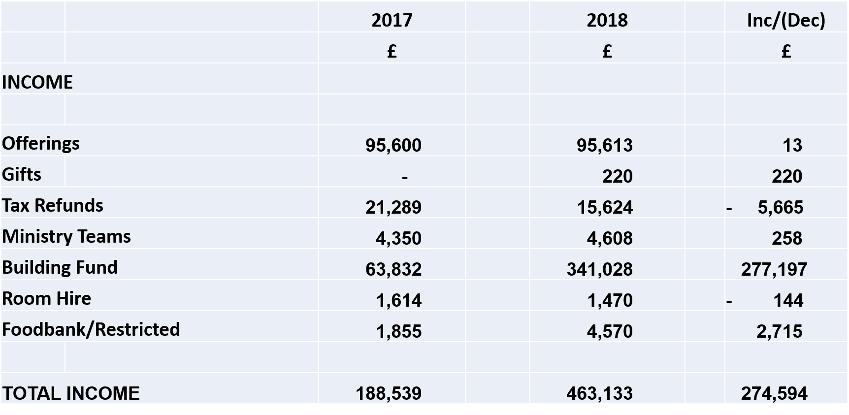

Expenditure Movements 2017-2018

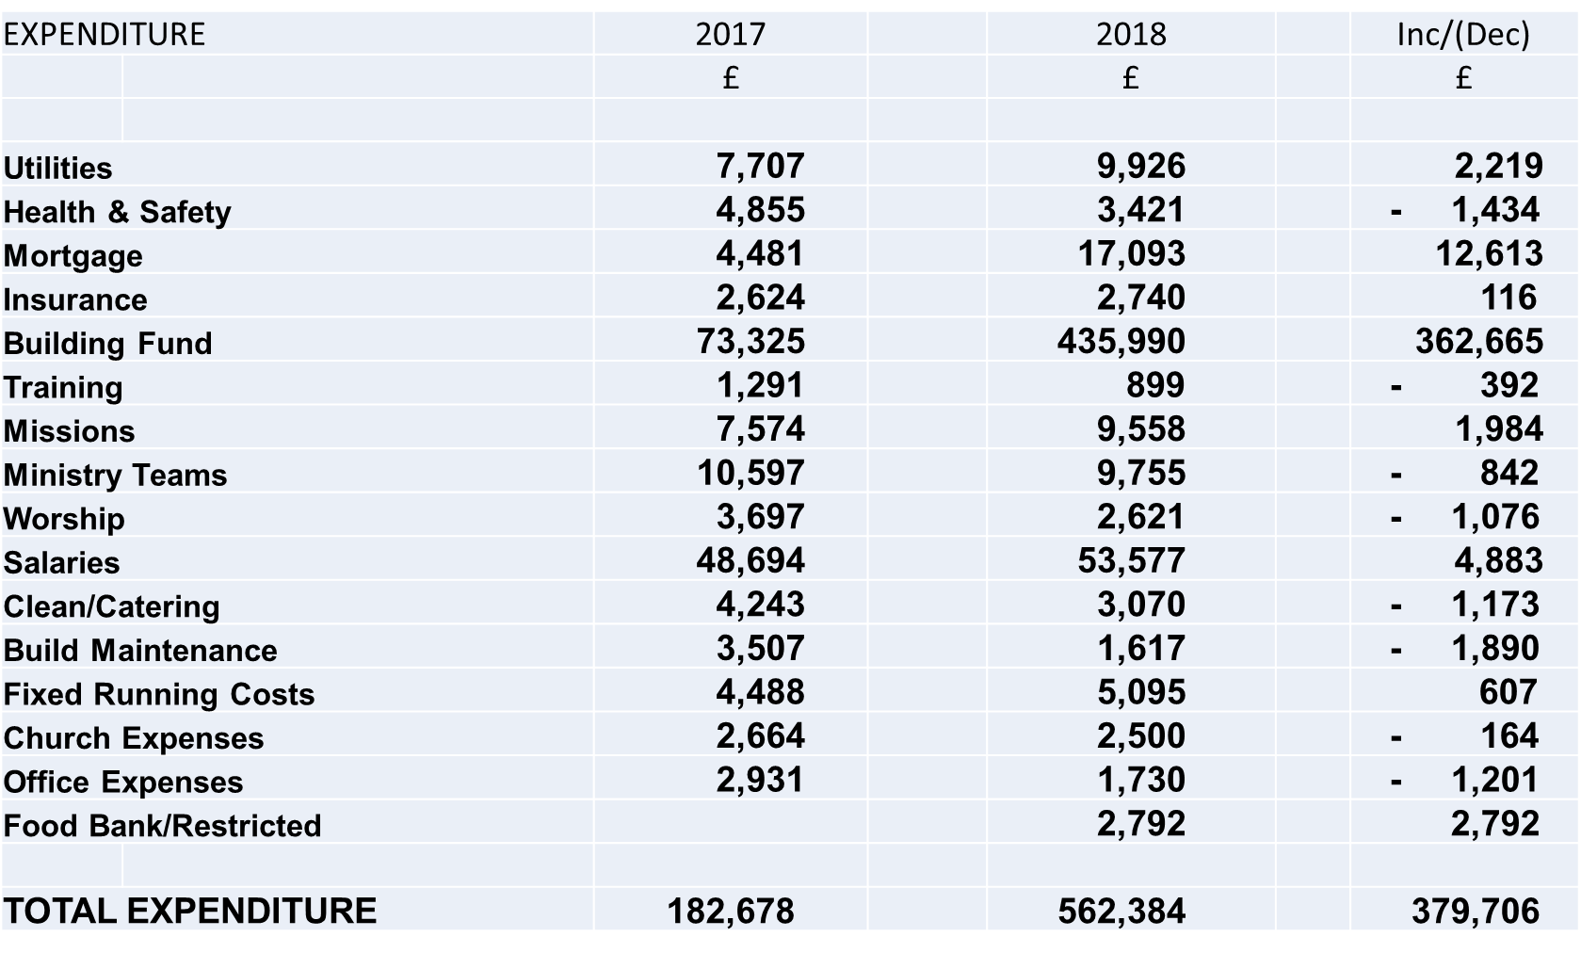

Income Movements - Jan to June 2019

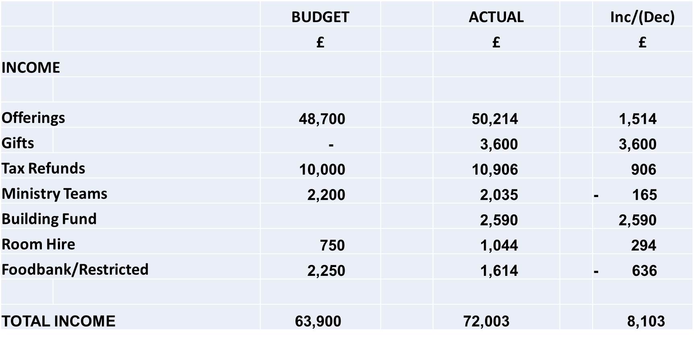

Expenditure Movements - Jan to June 2019

